Lab 7 Write-up
Jacob Ellis
DS 5030

I first started with a coarse scan of the numbers [15, 45, 60, 75, 80, 85, 90, 100] and added in the ‘free’ results from the earlier scans at $25 and $30. With this, I got a decent view of the plot and was able to see the beginnings of the overall curvature, specifically with peaks at price points around $75 and $45. At this point I have used 8 tests. The next step, I made some comparisons around the earlier observed peaks at $45, $75, and $90 for good measure. Adding the data from these tests to the graph reinforced the two peaks observation that I had made earlier.
The comparisons between $40 and $50 estimate the slope at around $45 very roughly, and the same is true for the comparison $70-$80. If zero slope is observed, then this is a maximum. Because the comparisons had 0 in their confidence intervals, it is reasonable to assume that both $45 and $75 are maximums in the data. This is what told me to stop my analysis.

Figure 1: Graph of market test revenues and errors
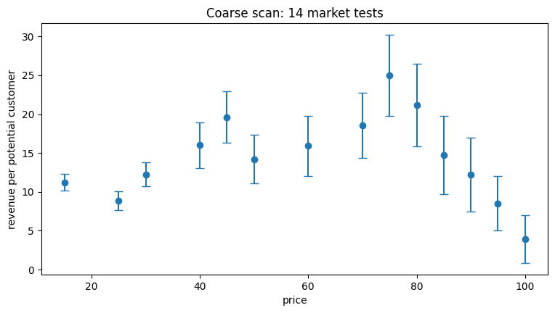
From the graph, observe the two peaks around $45 and $75. However, because the peak at $75 is higher, this is the recommended price point and has a revenue of $25 per customer. We are 95% confident that the revenue at price = $75 is between $19.79 and $30.21. This is not the same as a probability, but rather represents the results we would see if we ran this experiment many times.

